 | KNOWLEDGE INSTITUTE OF TECHNOLOGY  (An Autonomous Institution)  Department of Artificial Intelligence and Data Science  Organized by VIBES — Visionary Intellectuals Building Expert Systems | 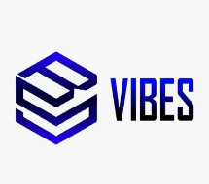

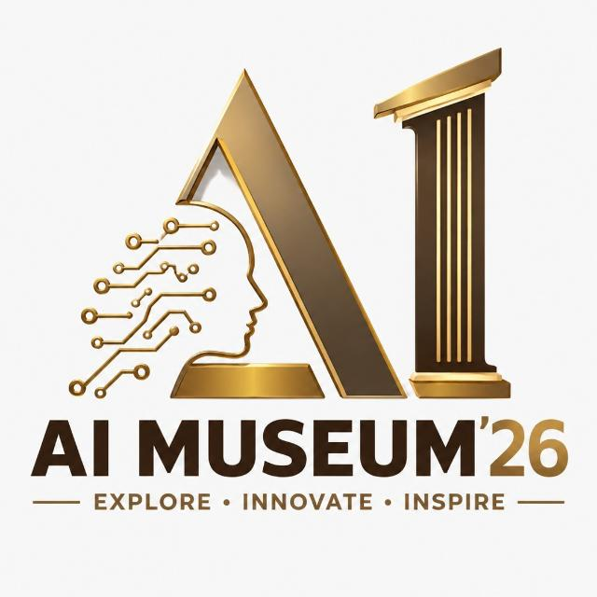 | AI MUSEUM’26  Explore • Innovate • Inspire | PROJECT SHOWCASE CARD  Zone No.: ______

PROJECT NAME: AI MUSEUM WELCOME ROBOT - VISION AND VOICE GUIDE
Domain: Embodied AI / Computer Vision / Robotics

 | PROBLEM STATEMENT  Museum visitors need quick, friendly guidance, but a human guide cannot always greet everyone, answer repeated event questions and manage safe movement.  SOLUTION & HOW IT WORKS  • Core AI: YOLO26n vision, Sarvam voice AI and ESP32 safety control  • Working: Camera -> Visitor / VIP detection -> Safe greeting -> Voice question -> Event-grounded answer  • Data: Event schedule, facilities and 17-project catalog; consented VIP profiles stored locally  KEY FEATURES  • Vision-guided greeting with YOLO26n and three-frame VIP verification  • Speech-to-text, event-grounded Q&A and natural TTS responses  • Safety-first movement: ultrasonic stop, wheel encoders, E-stop and watchdog
  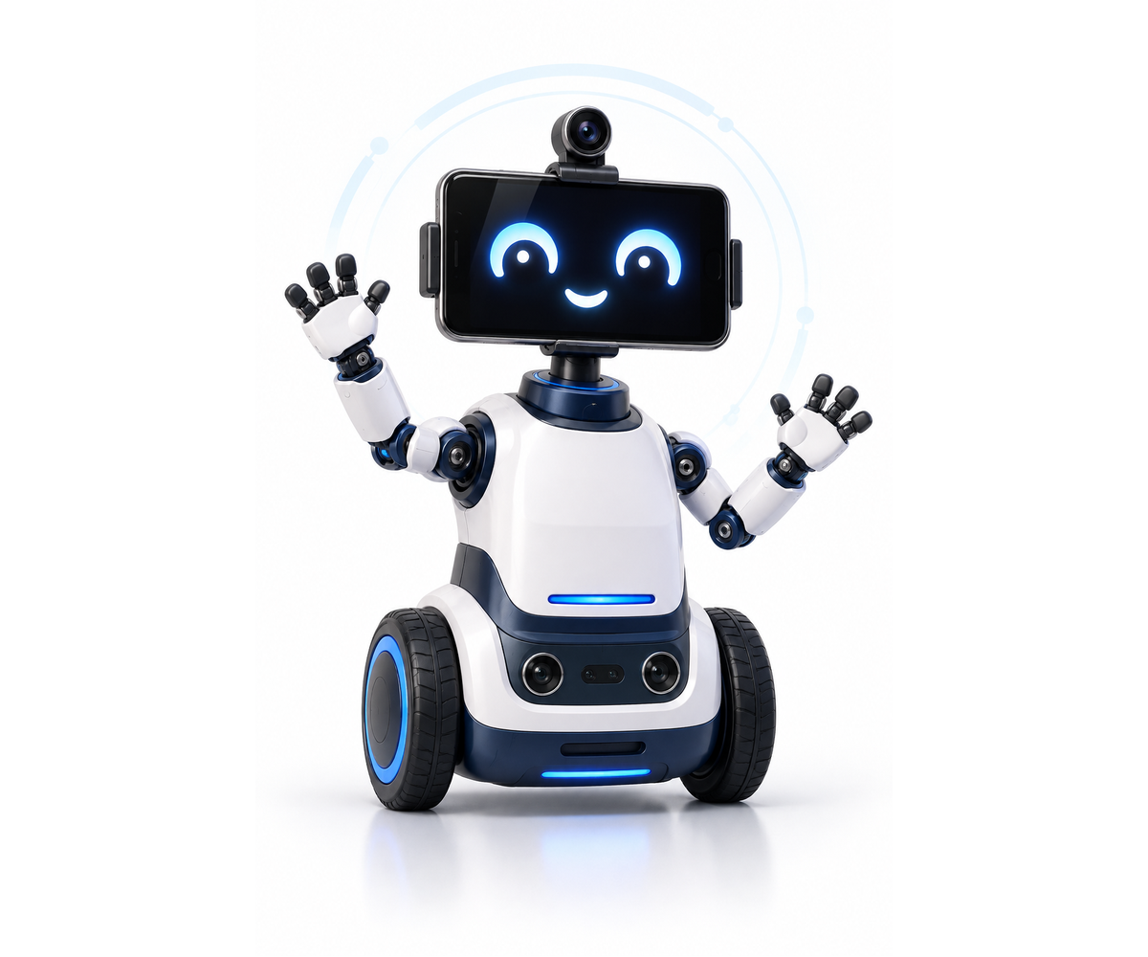
   | Status:  ☑ Prototype
    LIVE
    DEMO

TECH STACK
Python | FastAPI | ESP32 | YOLO26n | OpenCV | Sarvam AI | DroidCam

REAL-WORLD APPLICATIONS  • Museum reception and visitor guidance  • Event information and exhibit Q&A  • Campus, lab and exhibition assistance | TEAM & GUIDANCE  Team Members: Subhatra R K , Naveegaa N, Noor He Nihar M ,Vinothini G,Varshini M ,Vishal R  Mentor / Guide: Name, Designation  Contact: email / phone (optional)

AI MUSEUM ’26 • Dept. of Artificial Intelligence & Data Science • Organized by VIBES • KIOT

